**Power Generation through Footstep**

**CHAPTERS PAGE NO**

1. Abstract 2
2. Introduction -Brief description of the Work 2
3. Objective of the Work 3
4. Software and Hardware Requirements 3
5. Description of Components Required 3-5
6. Circuit Diagram 6
7. Screen Shots and Video Link 7
8. Applications of the Work 8
9. Future Work 8
10. Conclusion 9
11. **Abstract:** In the present scenario, the requirement for energy has been increasing in a distressing rate and the availability of the energy resources are not abundant for sustainable development and the is to establish an economical pollution free inexhaustible energy resource to compensate the increasing demands. The system generates electricity through the beats of human feet using piezoelectric materials. The pressure due to human weight when applied in the system could be converted to electrical energy for immediate/later use. The system is suitable where there are high volumes of human traffic such as markets, worship centres, shopping malls, bus stations, dancing stages, and parks. It can also be used in powering small electrical appliances and electronic gadgets such as cell phones, radio stereo, television, fan, and streetlights. Since, walking is the most common activity in human day to day life, whenever a person walks, he exhausts energy to the ground which goes as a waste. Hence to make use of this energy, we are converting it into electrical energy using piezoelectric effect. Piezoelectric effect is utilized by piezoelectric sensor producing output energy in the form of AC voltage.
12. **Introduction**

There are many potential alternative and renewable sources energy like solar, wind, biomass, and geothermal energy. Most unfortunately, human energy that could have been converted into electrical energy for use at least by the small-scale business outfits, markets religious centres, event centres, club houses, bus stations and parks, etc., are being wasted on daily basis. The ability to develop this system of generating electricity through the human foot beats as an alternative to conventional electricity supply could go a long way in boosting the economic potential of country. Therefore, a system of generating electricity through the footsteps of people by converting the foot power applied on the stairs to electrical energy, is stored in a battery and is used for activating the connected loads. The conversion from kinetic energy to electrical energy is achieved by placing a mechanical footstep power generator (piezoelectric) on the hind foot region. The result showed that generated power increased proportionally with the mass of an individual. The ability to develop this system of generating electricity through the human foot beats as an alternative to conventional electricity supply could go a long way to boosting the economic potential of country. Therefore, this system was aimed at generating electricity through the footsteps.

1. **Objective**

The objective of footstep power generation project is to extract renewable energy. If this project is installed in highly dense areas such as railway stations, clubs, parks etc, then maximum amount of energy can be extracted from it by simply walking on the area designed. The footstep power generation system is to capture the typically wasted energy surrounding a system and transforming it into electrical energy. The technique used in gaining the energy is via piezoelectric material.

1. **Software and Hardware Requirements**

Hardware Requirements: 1. Arduino Uno

2. Piezoelectric

3. Soldering cable

4. Bridge Rectifier

5. LCD 16x2 with I2c

6. 4C05 Bluetooth module

7. lithium Battery 110x2

8. Diode

9. Charger controller (TP4056)

Software Requirements**:**  Arduino uno IDE software

1. **Description of Components Required**

* Arduino Uno - Arduino UNO is a low-cost, flexible, and easy-to-use programmable open-source microcontroller board that can be integrated into a variety of electronic projects.

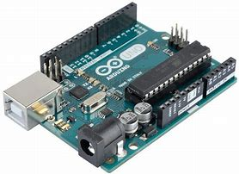

* Piezoelectric -Piezoelectricity is the process of using crystals to convert mechanical energy into electrical energy, or vice versa.

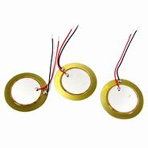

* Soldering cable - Solder is a means of ensuring a complete electrical connection, the solder will also protect the conductor from oxidisation at the point of contact.



* Bridge Rectifier - Bridge Rectifier converts the alternating current generated by the alternator into direct current to supply power to electrical equipment and components.

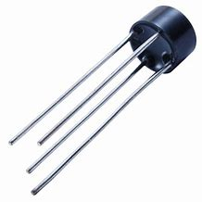

* LCD 16x2 with I2c - This is a 16x2 LCD display screen with I2C interface. It can display 16x2 characters on 2 lines, white characters on blue background.

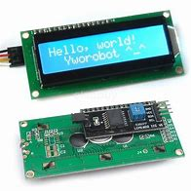

* 4C05 Bluetooth module - Bluetooth Module is an easy-to-use Bluetooth SPP (Serial Port Protocol) module, designed for transparent wireless serial connection setup.

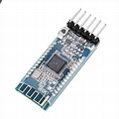

* lithium Battery 110x2 - A lithium-ion battery or Li-ion battery is a type of rechargeable battery composed of cells in which lithium ions move from the negative electrode through an electrolyte to the positive electrode during discharge and back when charging.

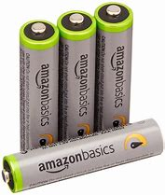

* Diode - A semiconductor device with two terminals, typically allowing the flow of current in one direction only.

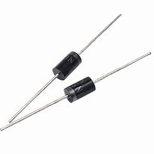

* Charger controller (TP4056) - TP4056 module is a linear charger lithium-ion battery. This module can charge batteries consists of single cells. Most importantly, it supports constant current and constant voltage modes of charging operations.

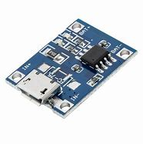

1. **Circuit Diagram**

1. **Screen Shots and Video Link**

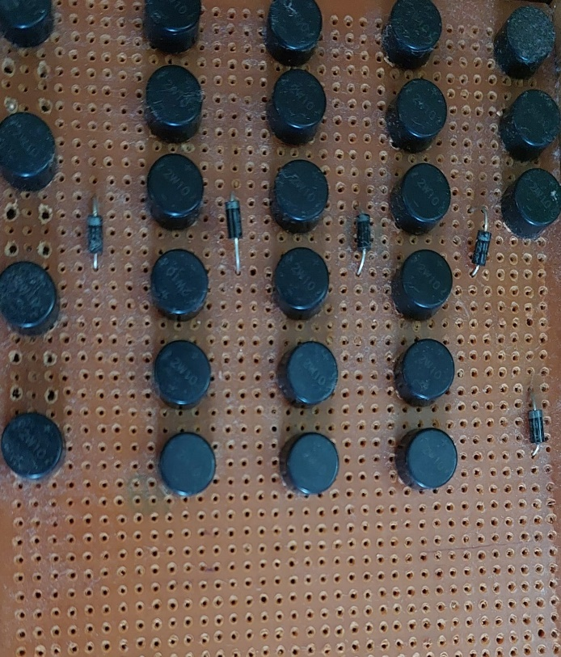

**Video link:**

[**https://www.youtube.com/watch?v=n6FFnJVq5cQ**](https://www.youtube.com/watch?v=n6FFnJVq5cQ)

1. **Applications of the work**

The proposed system can be used in most of the places such as:

1. Home appliances, street, cinema theatre, airports.
2. Emergency power failure situations.
3. Metros, rural places, bus stands, railway stations, shopping complex.
4. It can be used as a source for both A.C and D.C applications.
5. It can be used in School and Universities.
6. Can be used as a UPS in case of emergency power failure.
7. **Future Work**

The current system generates electricity and is transmitted via diode, bridge rectifier, and TP4056 battery charger which is then stored in the battery as well as being consumed immediately.

Future work has been planned to enhance the system by displaying the amount of current generated which would be helpful to analyse actual amount of pressure required to generate certain amount of electricity that could make a way for further research.

Below is the brief sketch of the future work:

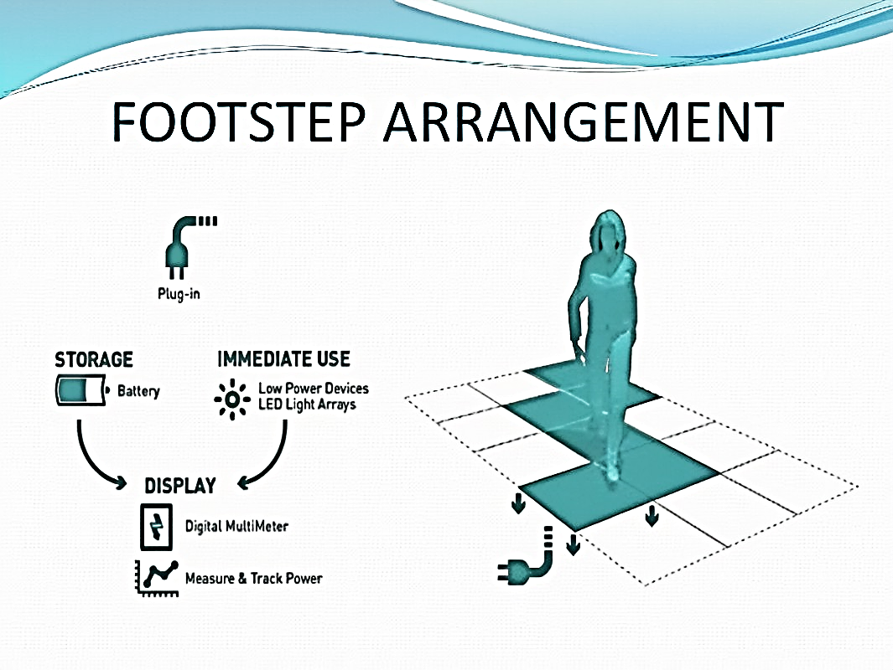

1. **Conclusion**

“Power Generation through footstep” has been successfully tested and concluded to be the best economical, affordable energy solution to common people. This can be used in many applications as mentioned above [8]. India is a developing country where energy management is a big challenge for existing population. This project can contribute to overcome such challenges.

Man has overused and wasted energy resources for his sustenance and well-being ever since he came on the earth a few million years ago. Proposal for the utilization of waste energy of foot power with human locomotion is very much relevant and important for highly populated countries like India and China in future, and the proposed system can be implemented with little advancements which can reduce the total cost and with increased reliability.

We can even integrate the system with solar system and form a hybrid system such that the cost of storage is reduced, and pure clean energy is produced with a high reliability.